Ahmet Ali BAĞCI  ahmetbgc@proton.me • +90 532 776 54 76 | 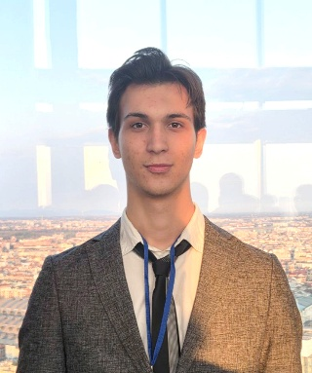

Education

- Kartal Anatolian Imam-Hatip High School  - IGCSE | 2018-2023  2019-2020
- Istanbul University  - Bachelor of Arts in Political Science and International Relations  - Erasmus Student Mobility  - Eberhard Karls Universität Tübingen | 2023-present  2025-present

Languages

- Turkish: native
- English: fluent (IELTS 7,5 score obtained in 2024)
- Chinese: reading and writing with limited speaking (HSK 4 obtained in 2025)

Certificates

- Four-week Program of International Chinese Language Teachers Scholarship at Shanghai University, July 14-August 8, 2025
- SETA Spring Seminars, April 14-May 21 2025
- European Youth Debate, March 26-28 2025
- The Summer School on the Protection and Promotion of Human Rights in the EU, July-August 2024
- The International Relations Summer School Programme, Afro-Eurasian Research Center Institute, September 16-27 2024
- ​2024 European Elections: Diplomacy Forum, April 23 2024
- Middle Level Chinese Language Course, Chinese Center Culture, 2023-2024
- The Conference for Israel's National Security Strategy, Istanbul University, October 28 2023

Scholarships

- The International Chinese Language Teachers Scholarship, July 14-August 10 2025

Extracurricular Activities

- Nuclear Strategy Reading Workshop, KUME, June 18-August 27 2025
- Competed in UNILIG Traditional Archery Target Competition, Istanbul, May 31 2025
- Sensory Art in Youth Work training course, December 2024-April 2025
- From Idea to Text Writing Workshop, Institute Social, January 22-February 5 2025, April 9-May 2 2025
- Istanbul Talimhane Archery Sport Club, February 9 2022- December 24 2024
- Competed in School Sports Turkey Championship Junior Man's Category, Karaman, May 18-19 2022
- Competed in School Sport Activities Archery City Contest Juniors Category and won the third place, Istanbul Okçular Vakfı, 25-29 April 2022
- Turkey Traditional Archery Federation Competed in Seniors Indoor Turkey Championship, Samsun, 25-27 February 2022
- Introduction to Quantum Computing Course, The Coding School, October 2020- May 2021
- Training for Combatting Information Disorder, June 16-30 2021

Skills
- Academic research and writing | - Negotiation | - Project execution
- Time management | - Leadership | - Translation

Additional Information

Areas of interest: Traditional archery, political history, linguistics

